1. Compare **D20** *(column AJ)* vs. **DPRx2** *(column AM)*

To compare the overall means of D20 and DPRx2 (discarding the observations with missing value of DPRx2), we conducted two-sample paired t-test (the two measurements are done on the same patients). The result is list below.

> t.test(D20,DPRx2, data=data, na.omit=T,paired=T)

Paired t-test

data: D20 and DPRx2

t = 7.0222, df = 223, p-value = 2.607e-11

alternative hypothesis: true difference in means is not equal to 0

95 percent confidence interval:

427.4304 760.9200

sample estimates:

mean of the differences

594.1752

The p-value is very small (2.607e-11), thus the mean of D20 and DPRx2 are statistically different.

The mean for D20 is

> mean(data$D20)

[1] 1054.804

Then mean for DPRx2 is (the NAs are removed)

> mean(data$DPRx2,na.rm=T)

[1] 476.9583

But when comparing D20 and DPRx2, we remove all the observations with NA in DPRx2 (there is no missing in D20), after removing those observations, there are total 224 observations. The mean for D20 of these 224 observations is

> mean(new_data$D20)

[1] 1071.134

When comparing the means of D20 and DPRx2, I used the new data with the missing values removed.

1. Distribution of **DPRx2** *(column AM)* per **GOS** *(column I)*

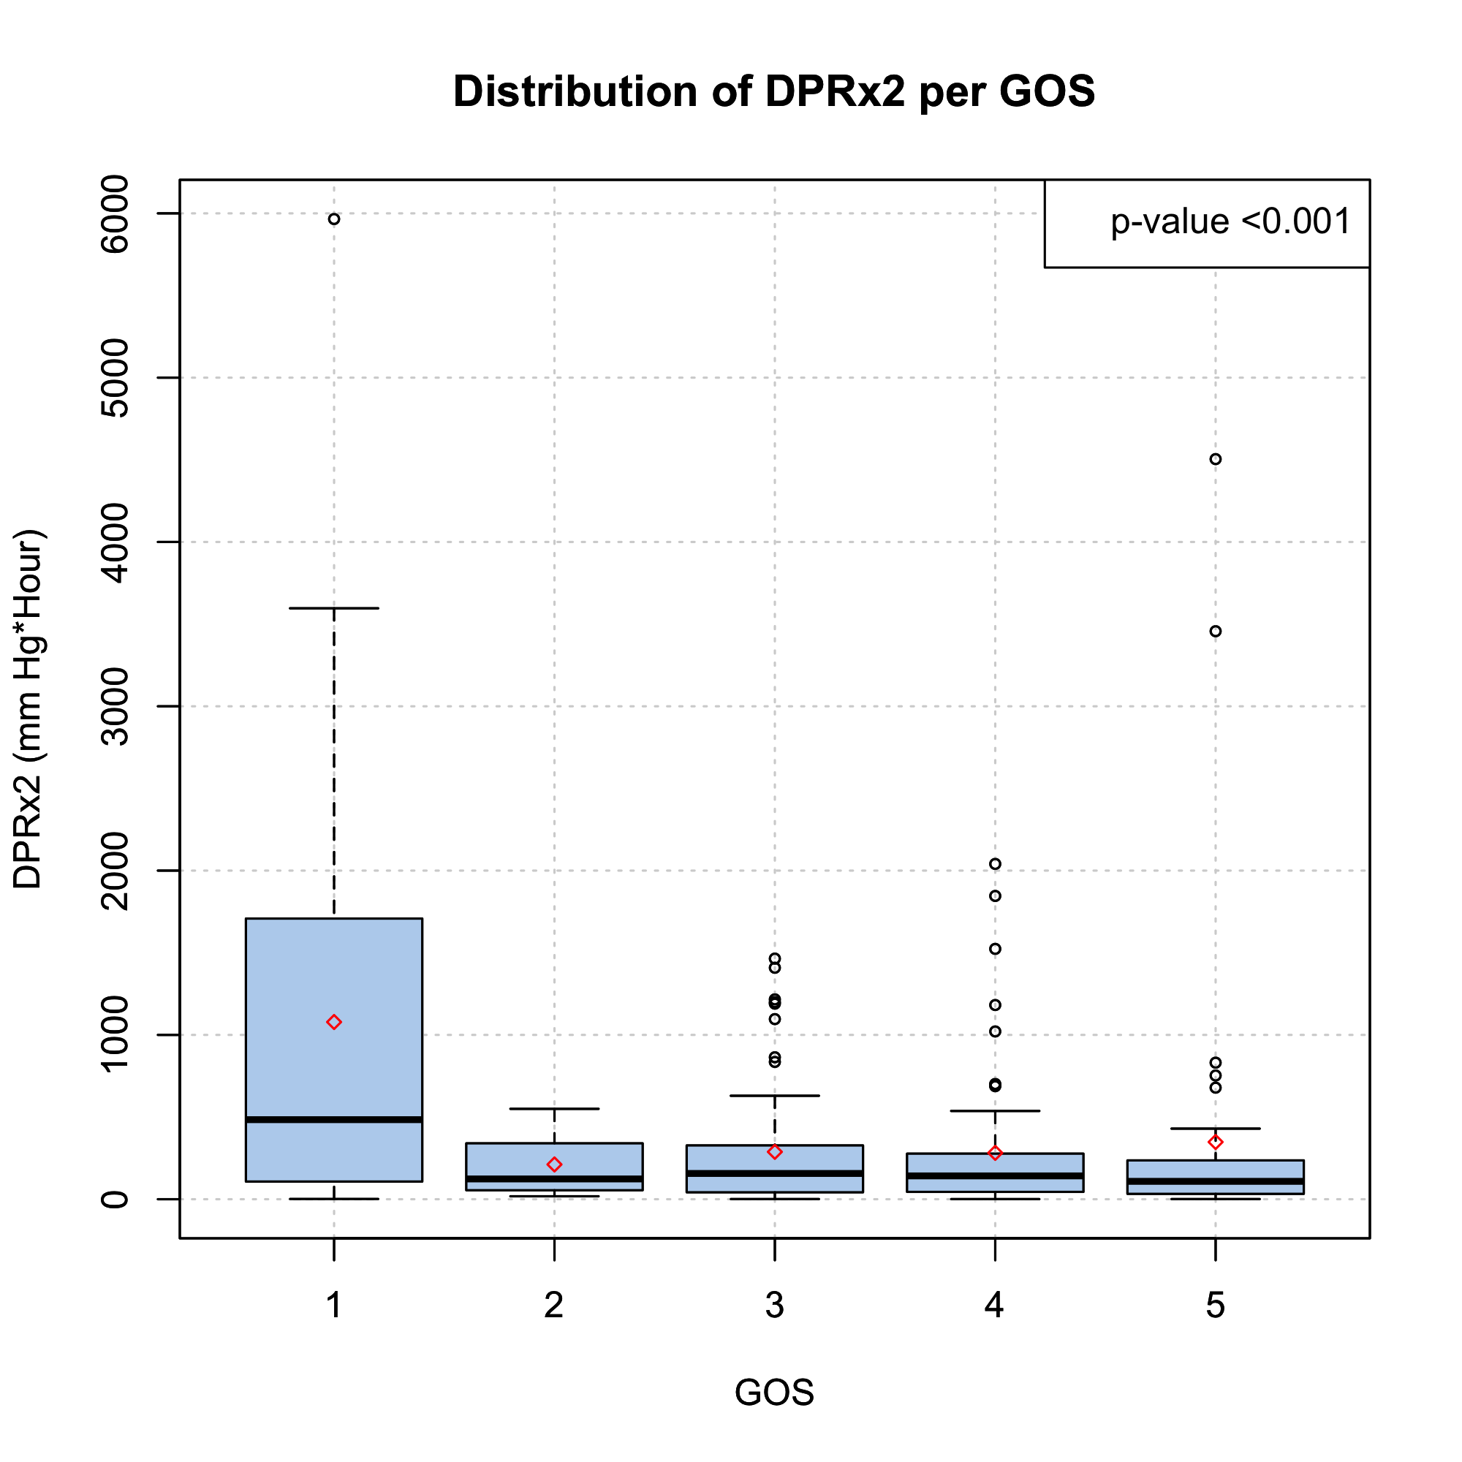

The red symbol stands for the mean of DPRx2 for each GOS group.

The order of GOS has been reversed.

The p-value on the top-left corner stands for the Kruska-Wallis rank sum test for comparing the equivalence of the means fro the ~~6~~ 5 groups.

~~> kruskal.test(new_data$DPRx2~as.factor(new_data$GOS))~~

~~Kruskal-Wallis rank sum test~~

~~data: new_data$DPRx2 by as.factor(new_data$GOS)~~

~~Kruskal-Wallis chi-squared = 24.3429, df = 5,~~ **~~p-value = 0.0001865~~**

Kruskal-Wallis chi-squared = 23.1145, df = 4, p-value = 0.0001201

1. Scatterplot: 1. x axis: mean I**CP** (mm Hg, *column S*), y axis: **D20** (mm Hg*hour, *column AJ*), 2. x: **ICP** (mm Hg, *column S*), y: **DPRx2** (mm Hg*hour, *column AM*) (side by side in one figure)

